Day35&36 - Task17 - AWS RDS

Create MariaDB DB on EC2.
Launch an EC2 Instance
- Launch an Amazon Linux EC2 instance.
- Configure the security group:
  - SSH (22) → Source: My IP
  - Custom TCP (3306) → Source: My IP (only if you want to connect from your computer)
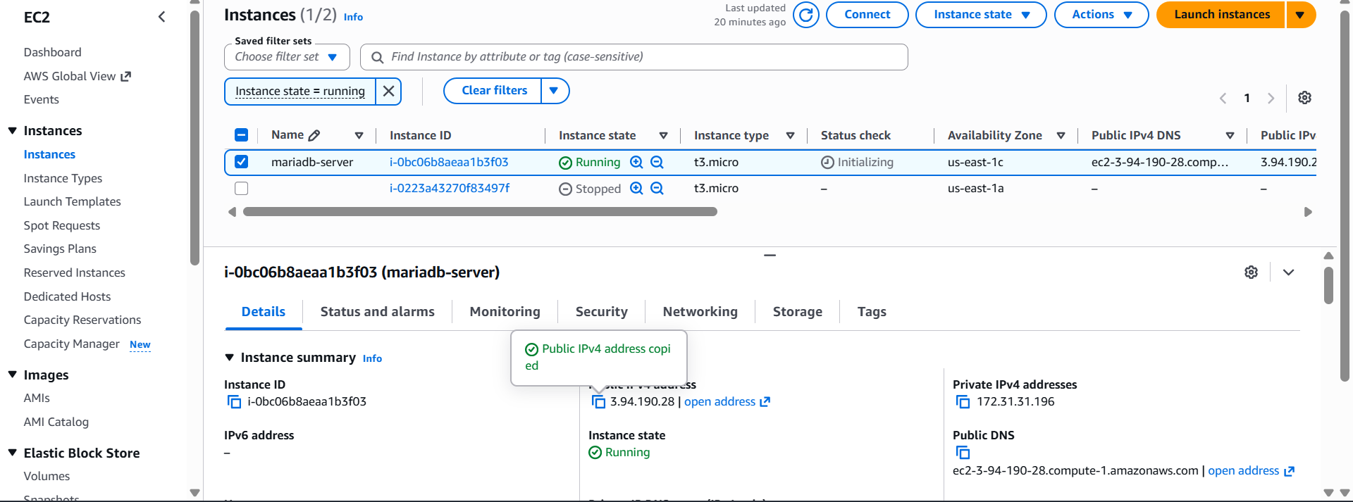
Connect to the EC2 Instance
ssh -i your-key.pem ec2-user@<EC2-PUBLIC-IP>
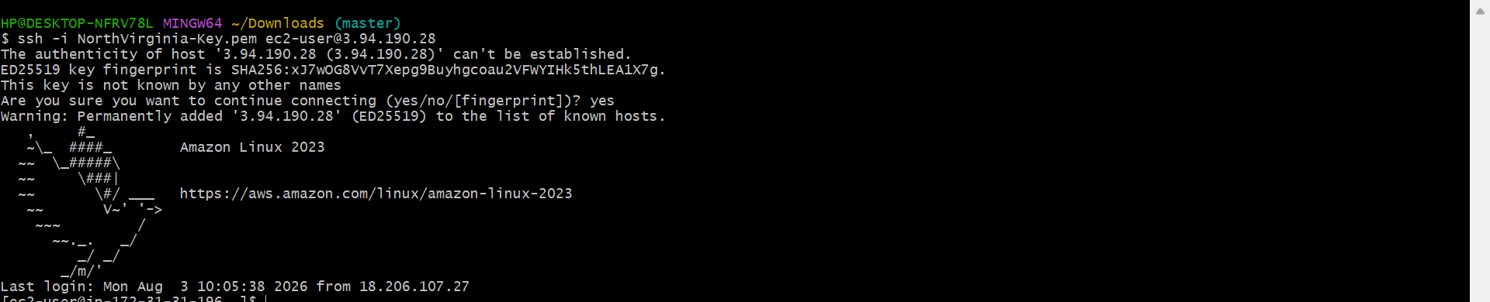
Update the System
sudo dnf update -y

Install MariaDB
sudo dnf install mariadb105-server -y
Verify the installation:
mariadb –version
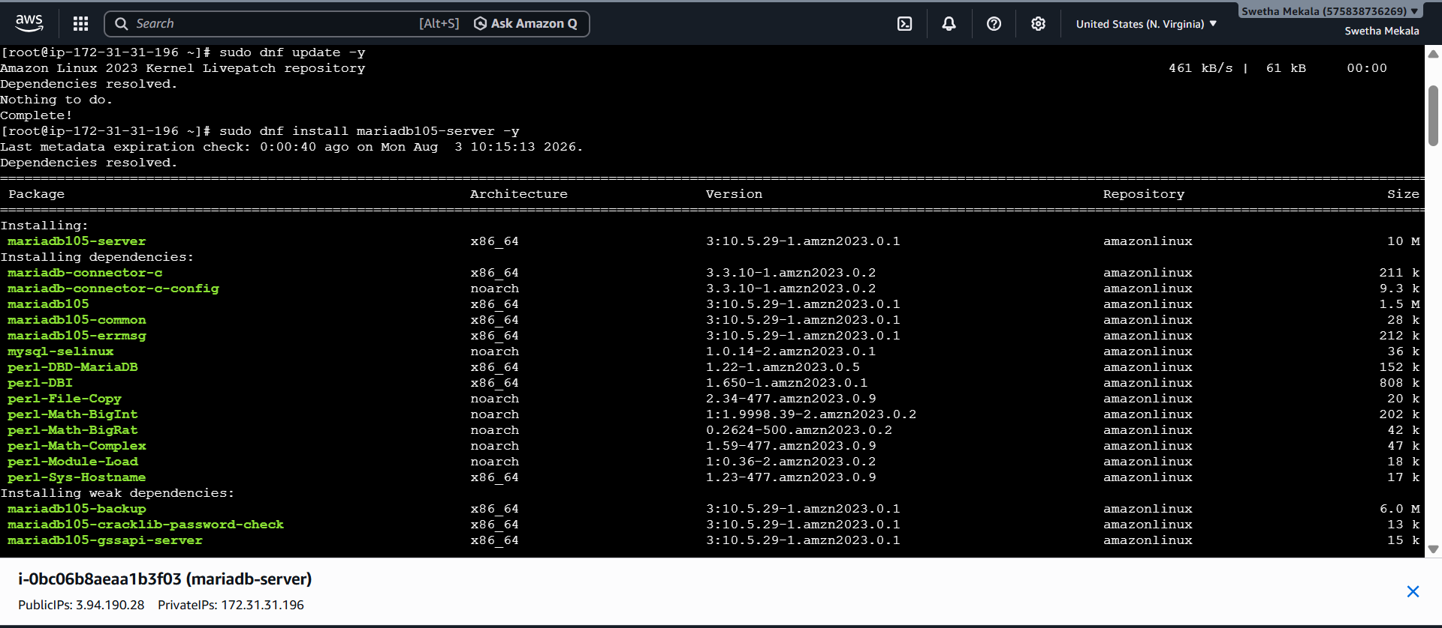
Start and Enable MariaDB
Start the service:
sudo systemctl start mariadb
Enable it to start automatically on boot:
sudo systemctl enable mariadb
Check its status:
sudo systemctl status mariadb
You should see:
Active: active (running)
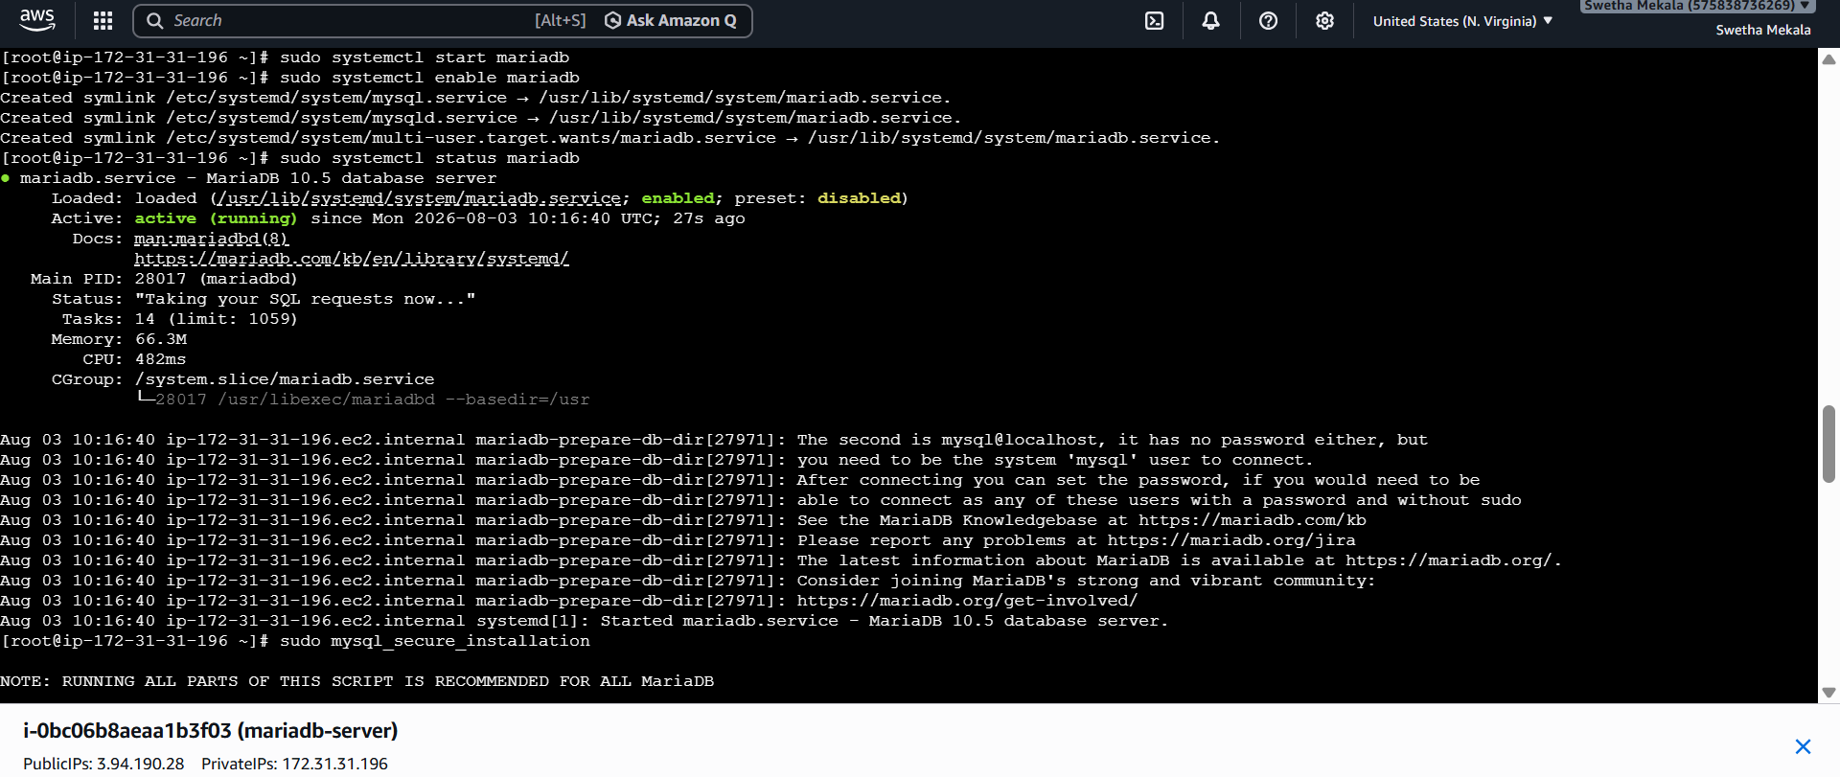
Secure the MariaDB Installation
sudo mysql_secure_installation
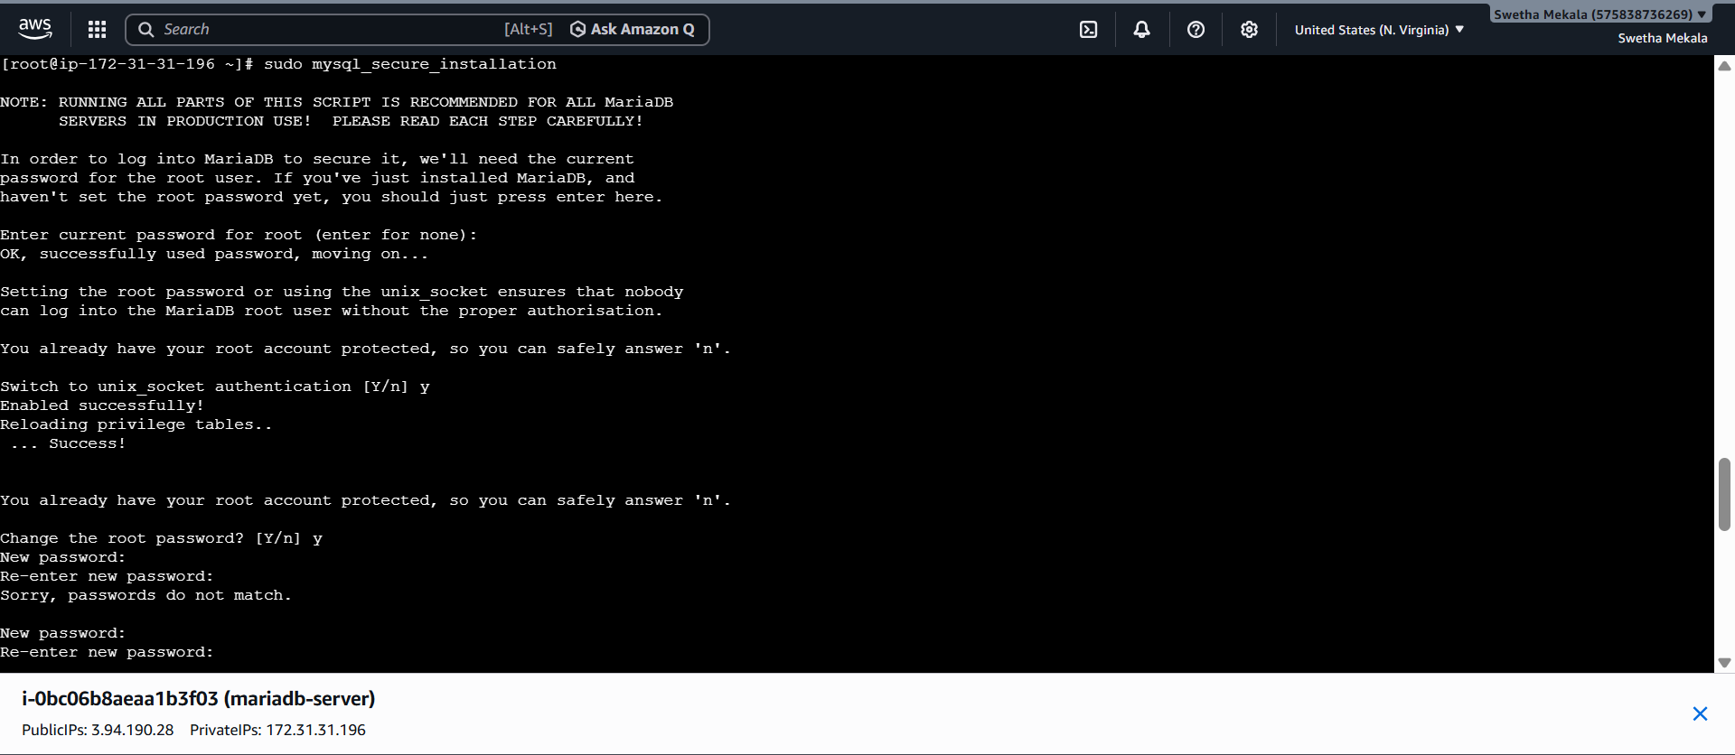
Log in to MariaDB
sudo mariadb
You should see:
MariaDB [(none)]>
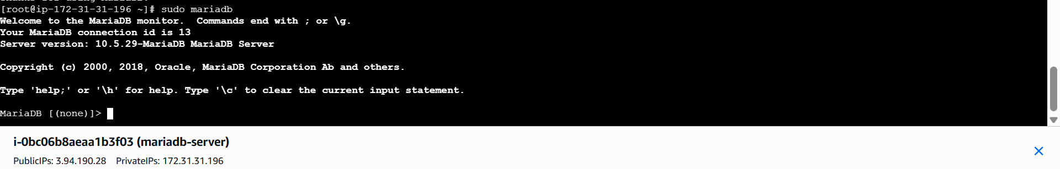
Insert some dummy data.
Log in to MariaDB
sudo mariadb
You should see:
MariaDB [(none)]>
Create a Database
Run:
CREATE DATABASE companydb;
Expected output:
Query OK, 1 row affected (0.001 sec)
Verify the Database Was Created
Run:
SHOW DATABASES;
Select the Database
Run:
USE companydb;
Expected output:
Database changed
The prompt will change to:
MariaDB [companydb]>
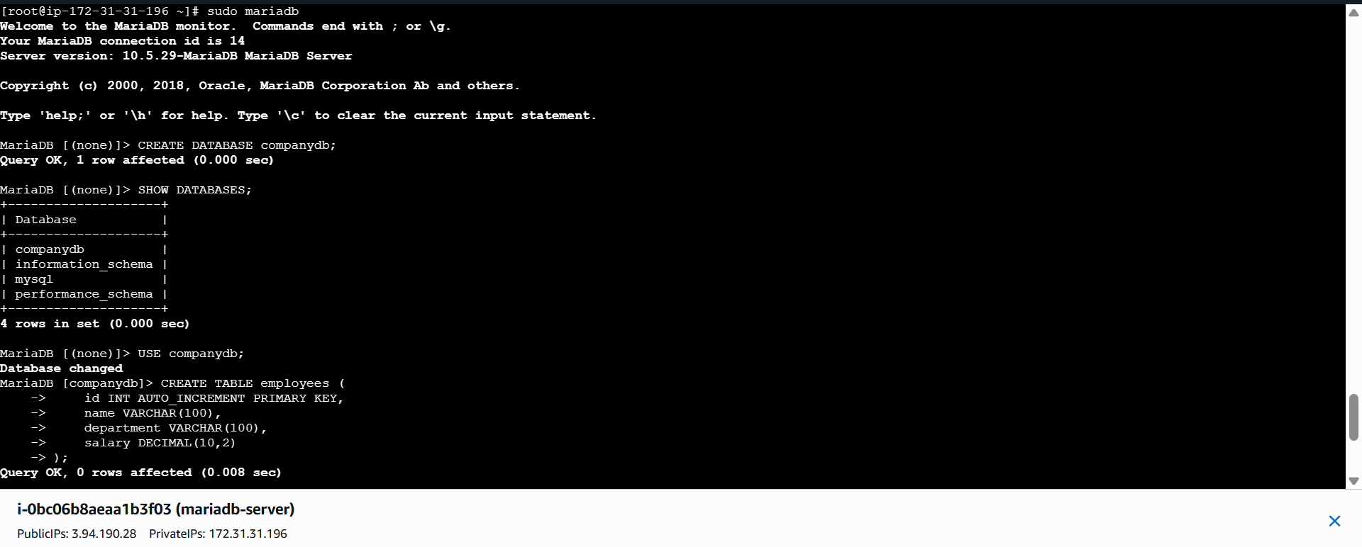
Create a Table
Run:
CREATE TABLE employees (
id INT AUTO_INCREMENT PRIMARY KEY,
name VARCHAR(100),
department VARCHAR(100),
salary DECIMAL(10,2)
);
Expected output:
Query OK, 0 rows affected
Insert Dummy Data
Run:
INSERT INTO employees (name, department, salary)
VALUES
('John', 'IT', 50000.00),
('Alice', 'HR', 45000.00),
('Bob', 'Finance', 60000.00);
Expected output:
Query OK, 3 rows affected
View the Data
Run:
SELECT * FROM employees;
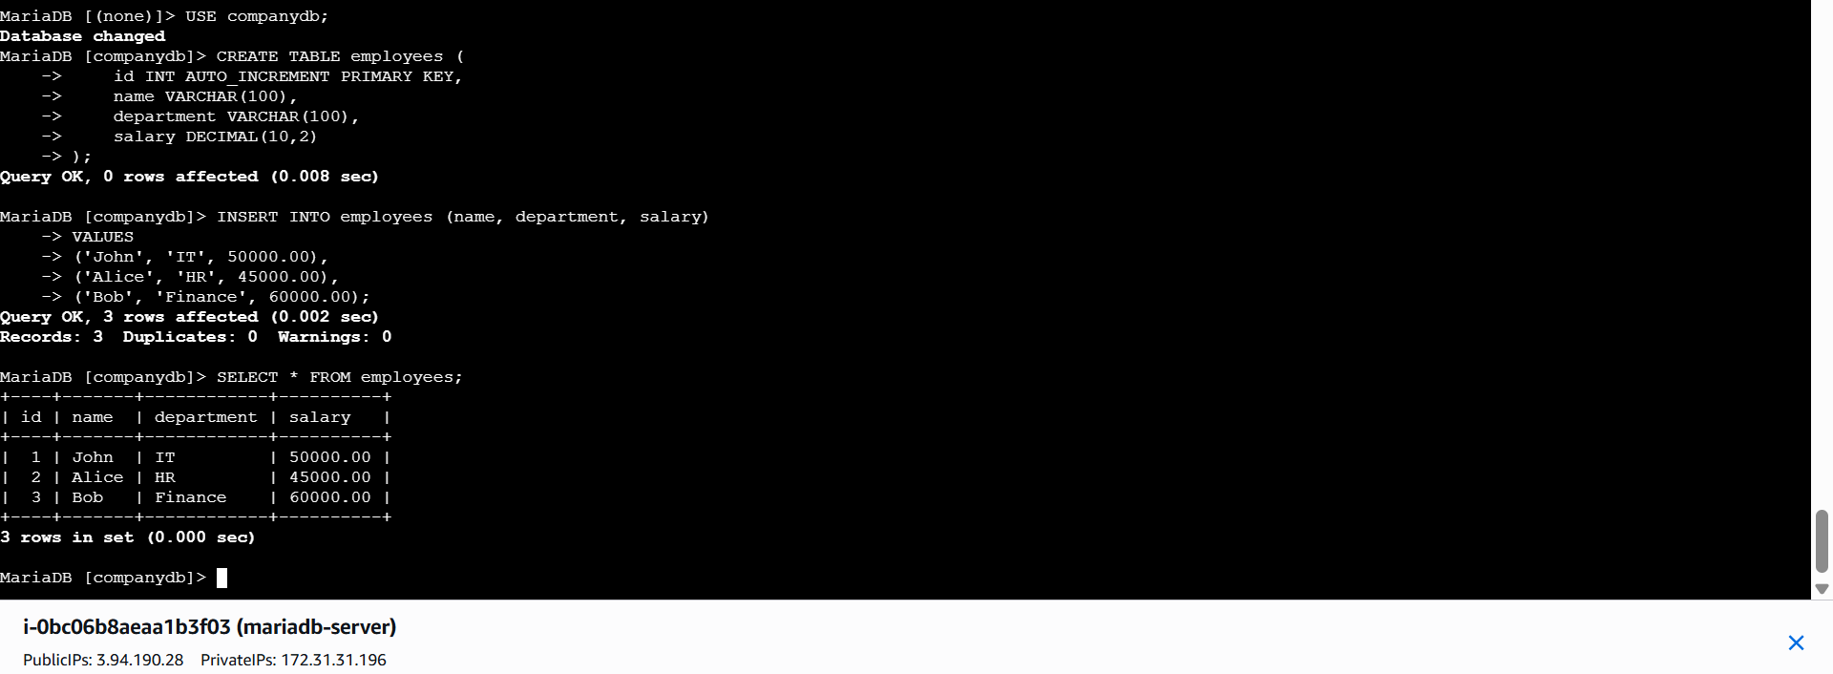
Take the backup of dummy data on EC2.
Log in to MariaDB:
sudo mariadb
Check the databases:
SHOW DATABASES;
You should see:
companydb
Exit MariaDB:
EXIT;
Take the Backup
From the Linux terminal (not inside MariaDB), run:
mysqldump -u root companydb > companydb_backup.sql
If your root user requires a password, use:
mysqldump -u root -p companydb > companydb_backup.sql
Verify the Backup File
List the files in your current directory:
ls -l
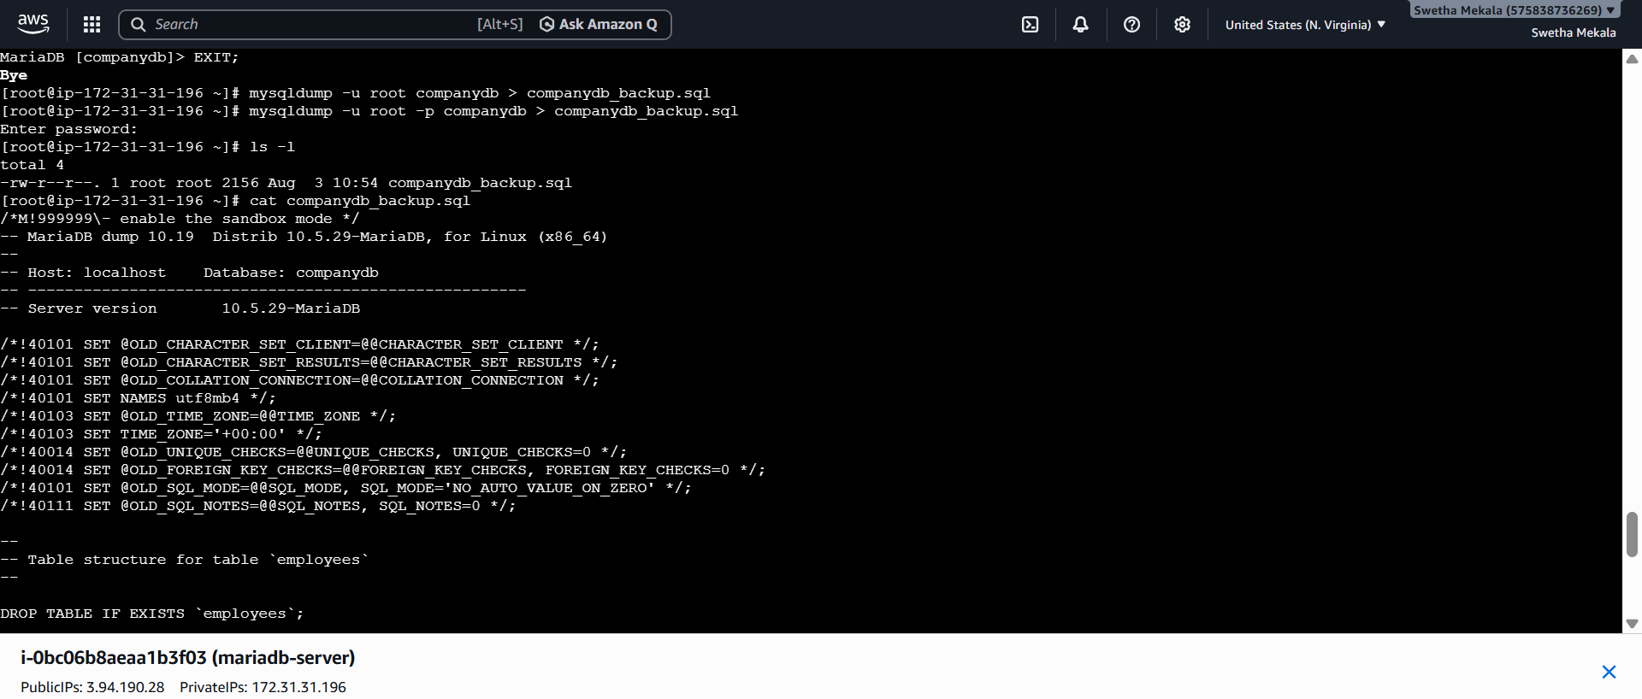
View the Backup File
cat companydb_backup.sql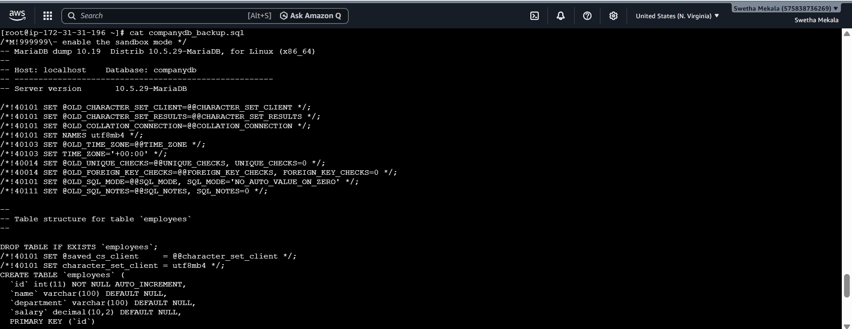
Check the File Size
Run:
du -h companydb_backup.sql
Example output:
4.0K companydb_backup.sql
Store the Backup in a Separate Folder
Create a backups directory:
mkdir backups
Move the backup file:
mv companydb_backup.sql backups/
Verify:
ls backups
Output:
companydb_backup.sql
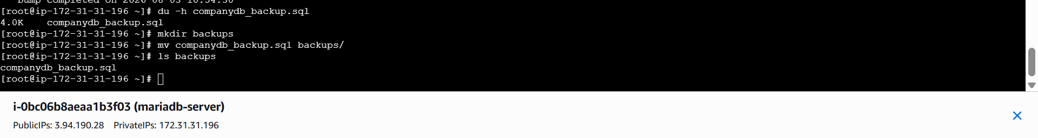
Launch MariaDB RDS instance.
Launch an Amazon RDS MariaDB Instance
- Log in to the AWS Management Console.
- Go to Amazon RDS.
- Click Create database.
- Select Standard create (Full configuration).
- Choose MariaDB as the database engine.
- Enter:
  - DB identifier: database-2 (or any name)
  - Master username: admin
  - Master password: Create and remember a password.
- Select a suitable instance class (for example, db.t4g.micro if available).
- Choose the same VPC as your EC2 instance.
- Attach or create a security group.
- Click Create database.
Wait until the status becomes Available.

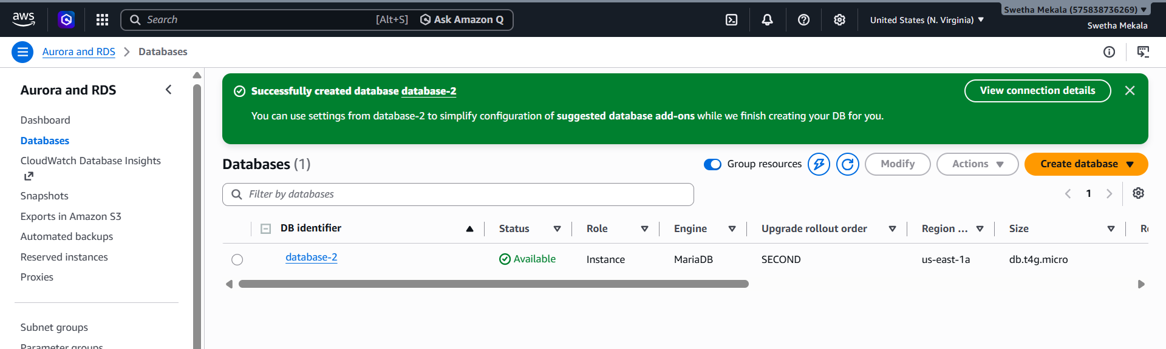
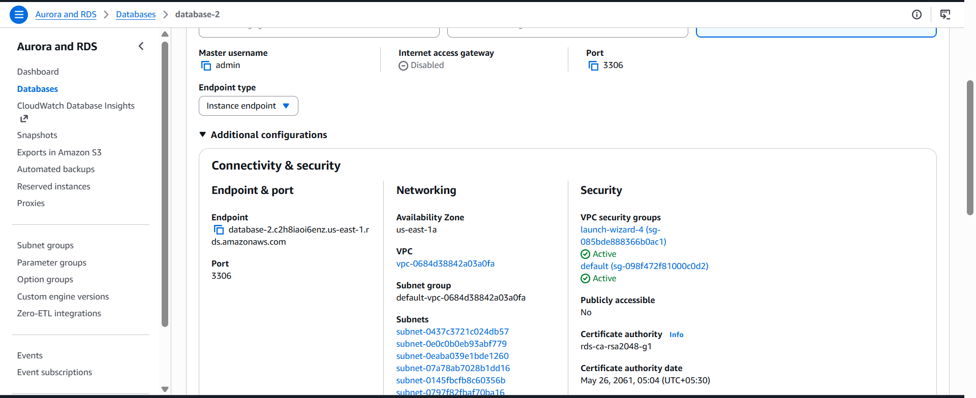
Migrate database from EC2 to RDS.
Configure the RDS Security Group
- Open your RDS instance.
- Go to Connectivity & security.
- Click the attached Security Group.
- Edit the Inbound Rules.
- Add a rule:
Type | Protocol | Port | Source
MySQL/Aurora | TCP | 3306 | EC2 Security Group (launch-wizard-4 in your case)
- Save the rules.
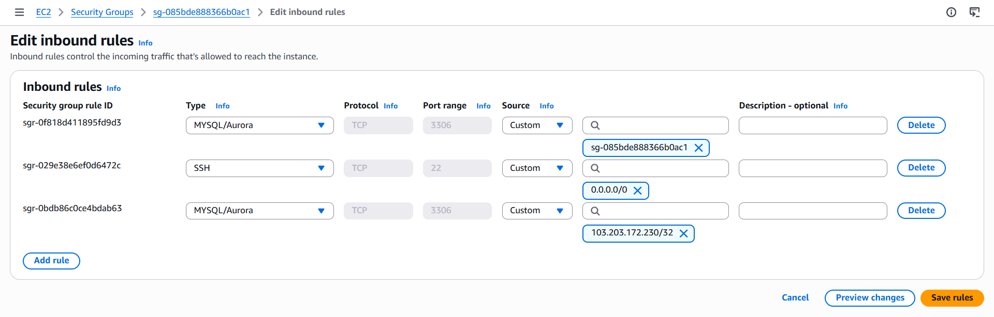
Download the AWS RDS SSL Certificate (on EC2)
Connect to your EC2 instance and run:
curl -o global-bundle.pem https://truststore.pki.rds.amazonaws.com/global/global-bundle.pem
This certificate is required because your RDS instance enforces secure (SSL/TLS) connections.
Connect to the RDS Instance
Run:
mysql -h database-2.c2h8iaoi6enz.us-east-1.rds.amazonaws.com \
-P 3306 \
-u admin \
-p \
--ssl-ca=global-bundle.pem
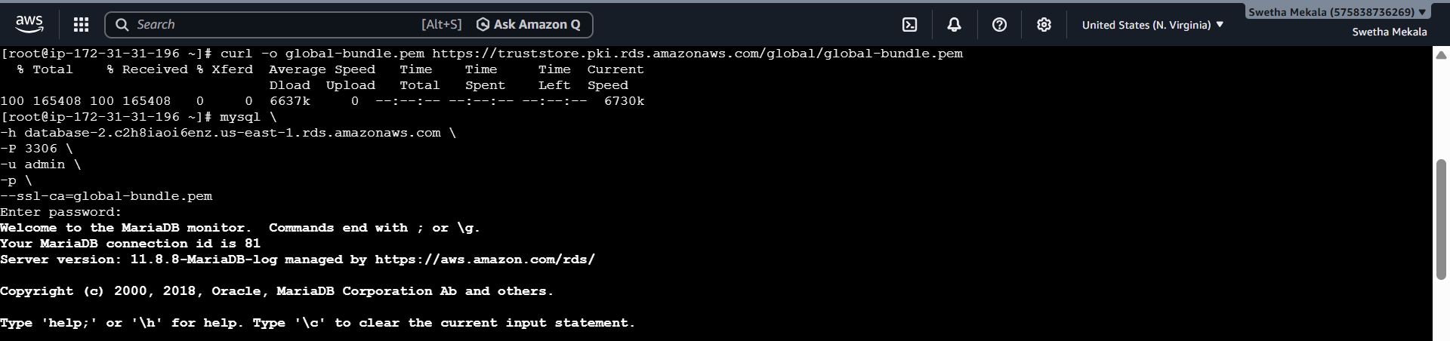
Create the Database on RDS
Check the databases:
SHOW DATABASES;
If companydb does not exist, create it:
CREATE DATABASE companydb;
Exit MariaDB:
EXIT;
Verify the Backup File on EC2
Check that the backup file exists:
ls -l backups
Expected output:
companydb_backup.sql
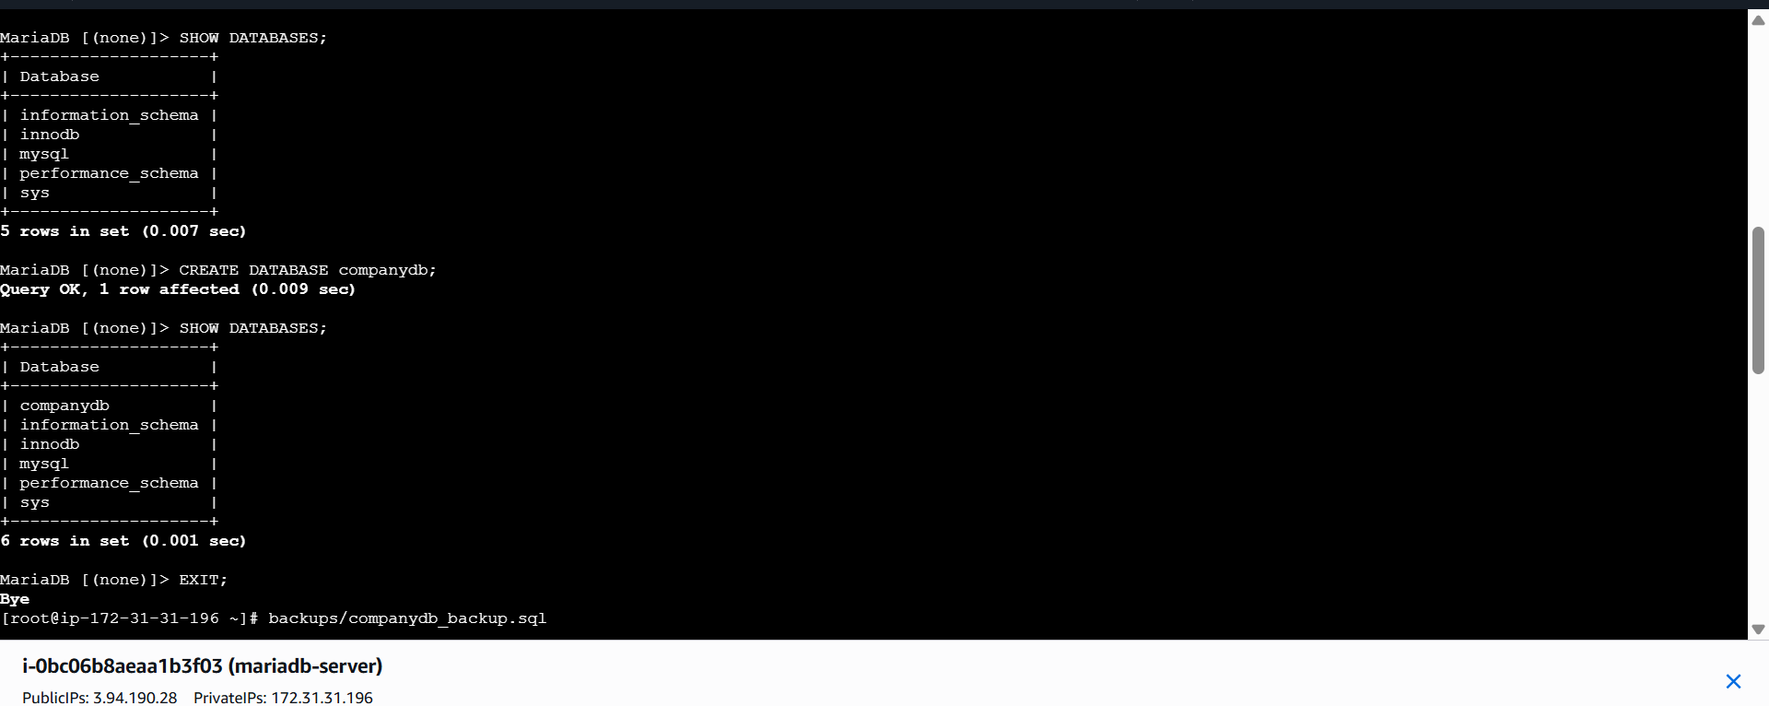
Import the Backup into RDS
mysql -h database-2.c2h8iaoi6enz.us-east-1.rds.amazonaws.com \
-P 3306 \
-u admin \
-p \
--ssl-ca=global-bundle.pem \
companydb < backups/companydb_backup.sql
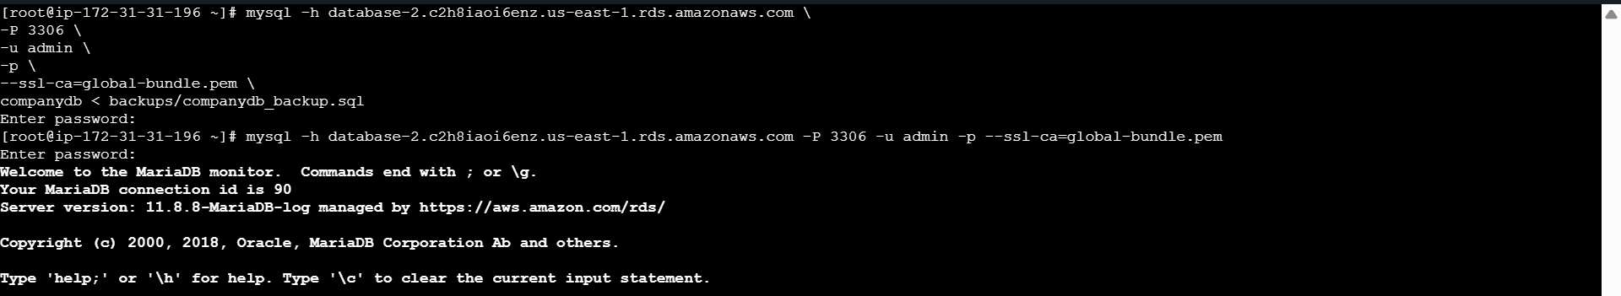
Verify the Migration
Connect to RDS again:
mysql -h <RDS-ENDPOINT> \
-P 3306 \
-u admin \
-p \
--ssl-ca=global-bundle.pem
Select the database:
USE companydb;
Check the tables:
SHOW TABLES;
Verify the data:
SELECT * FROM employees;
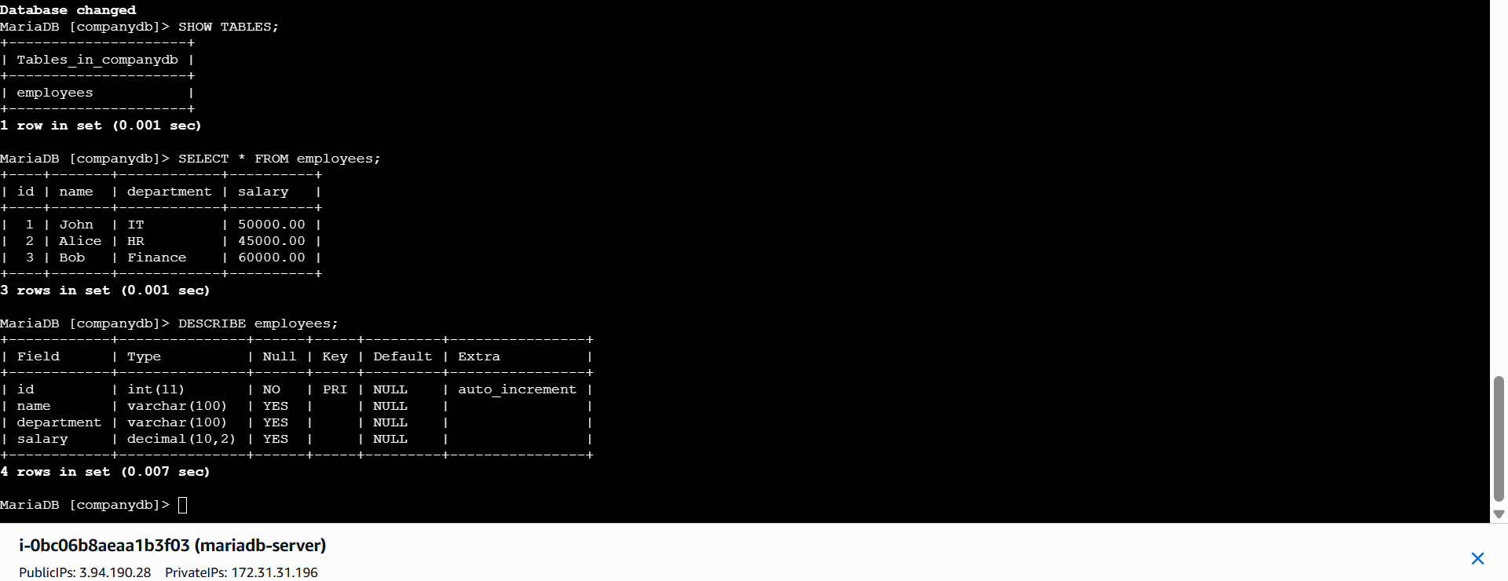
Install MySQL DB on EC2.
Launch an Ubuntu EC2 Instance
- Open the AWS Management Console.
- Go to EC2.
- Click Launch Instance.
Configure the instance:
Setting | Value
Name | mysql-server
AMI | Ubuntu Server 24.04 LTS (or 22.04 LTS)
Instance Type | t3.micro
Key Pair | Select your existing key pair
VPC | Default VPC
Subnet | Default subnet
Auto-assign Public IP | Enabled
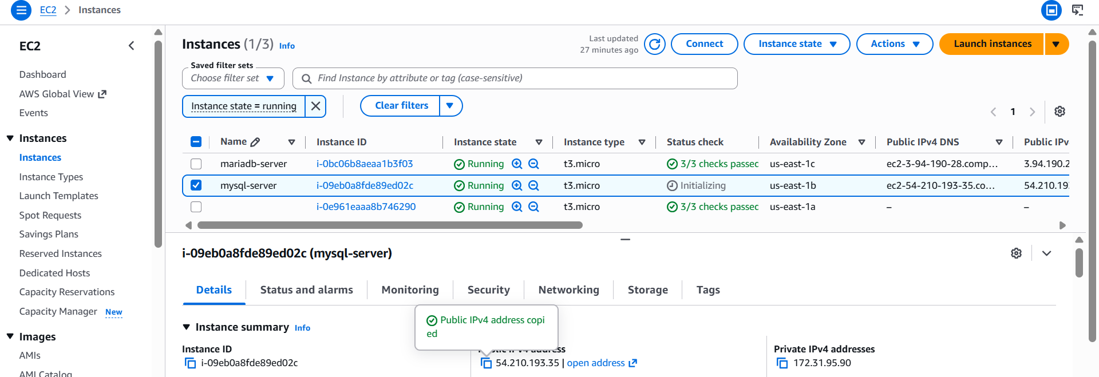
Connect to the EC2 Instance
Open a terminal on your local machine and connect using SSH:
ssh -i NorthVirginia-Key.pem ubuntu@<EC2-Public-IP>
Update the System
Update the package list:
sudo apt update
Upgrade installed packages:
sudo apt upgrade -y
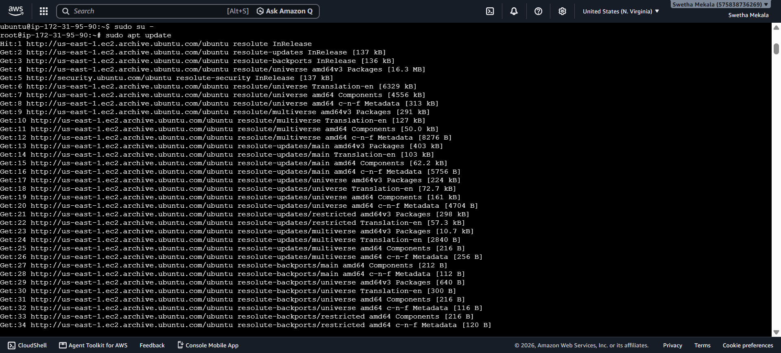
Install MySQL Server
Install MySQL:
sudo apt install mysql-server -y
Wait for the installation to complete.

Step 5: Check MySQL Service Status
Verify that MySQL is running:
sudo systemctl status mysql
Expected output:
Active: active (running)
Press Q to exit the status screen.
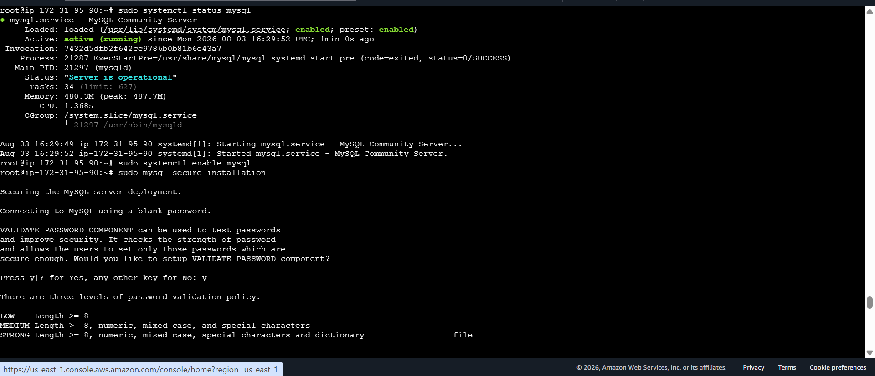
Secure the MySQL Installation
Run:
sudo mysql_secure_installation
Use these answers:
Prompt | Answer
Setup VALIDATE PASSWORD component? | Y
Password policy | 1 (MEDIUM)
Remove anonymous users? | Y
Disallow root login remotely? | Y
Remove test database? | Y
Reload privilege tables? | Y
On Ubuntu, you'll see a message that the root user uses auth_socket authentication by default. This is normal.
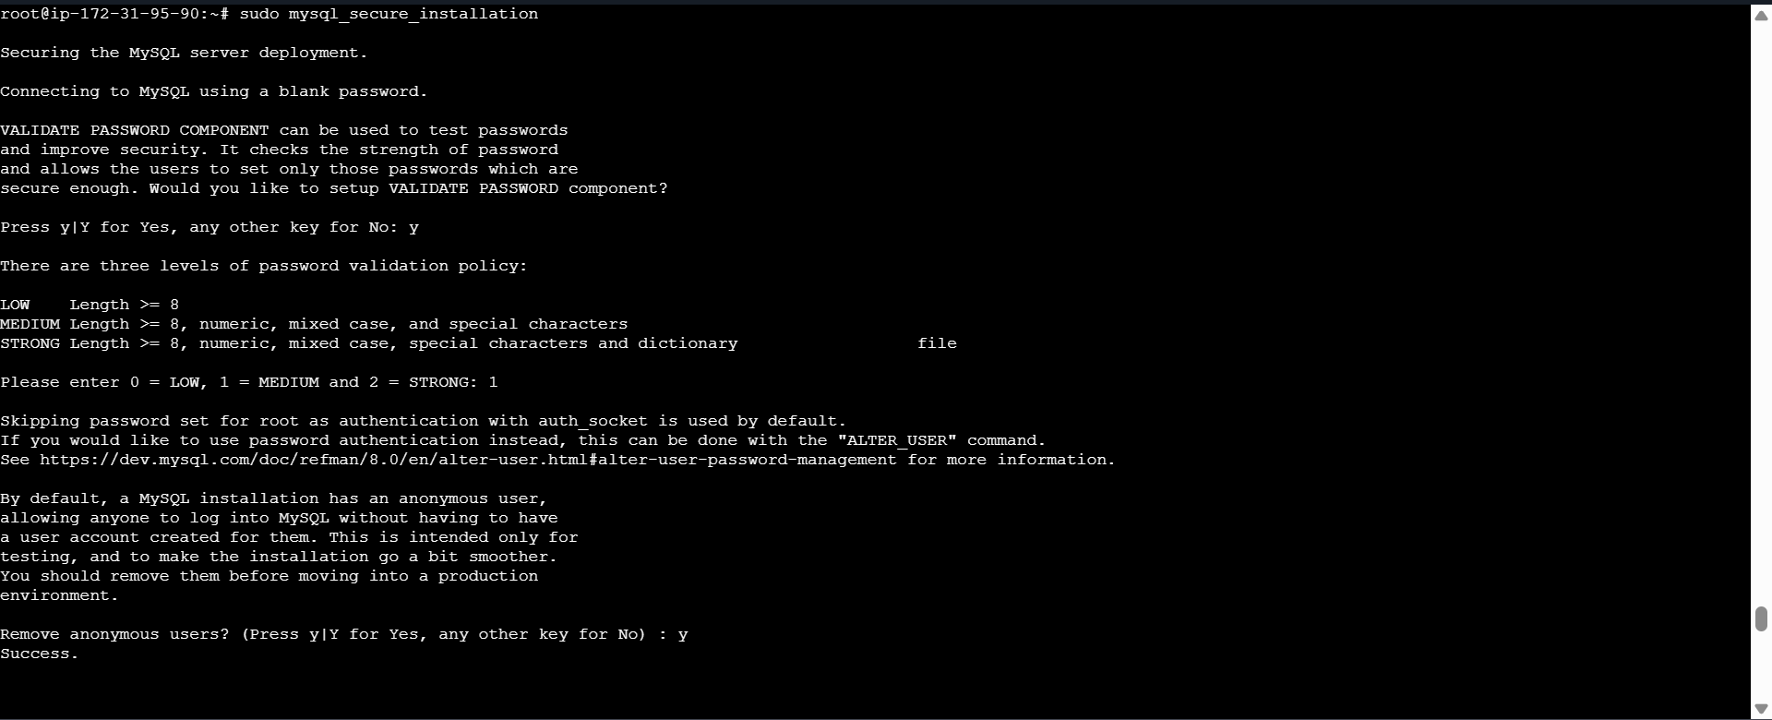
Log in to MySQL
Run:
sudo mysql
You should see:
Welcome to the MySQL monitor.
mysql>

Step 9: Verify the Installation
Check the MySQL version:
SELECT VERSION();
List the databases:
SHOW DATABASES;
Expected output:
information_schema
mysql
performance_schema
sys
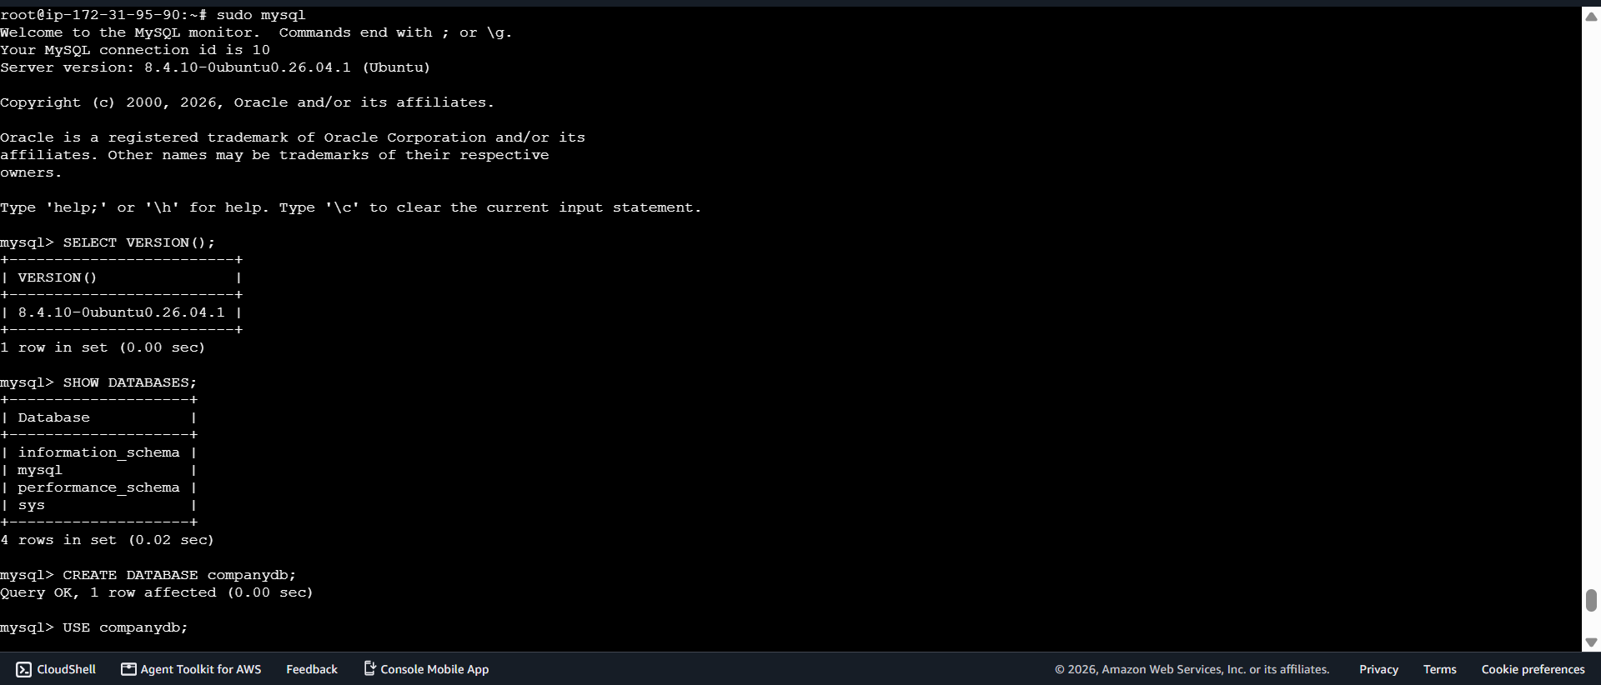
Create a Database
CREATE DATABASE companydb;

Step 11: Use the Database
USE companydb;

Step 12: Create a Table
CREATE TABLE employees (
id INT AUTO_INCREMENT PRIMARY KEY,
name VARCHAR(100),
department VARCHAR(100),
salary DECIMAL(10,2)
);

Step 13: Insert Dummy Data
INSERT INTO employees (name, department, salary)
VALUES
('Swetha', 'IT', 50000),
('Sudha', 'HR', 45000),
('Shiva', 'Finance', 60000);

Step 14: Verify the Data
SELECT * FROM employees;
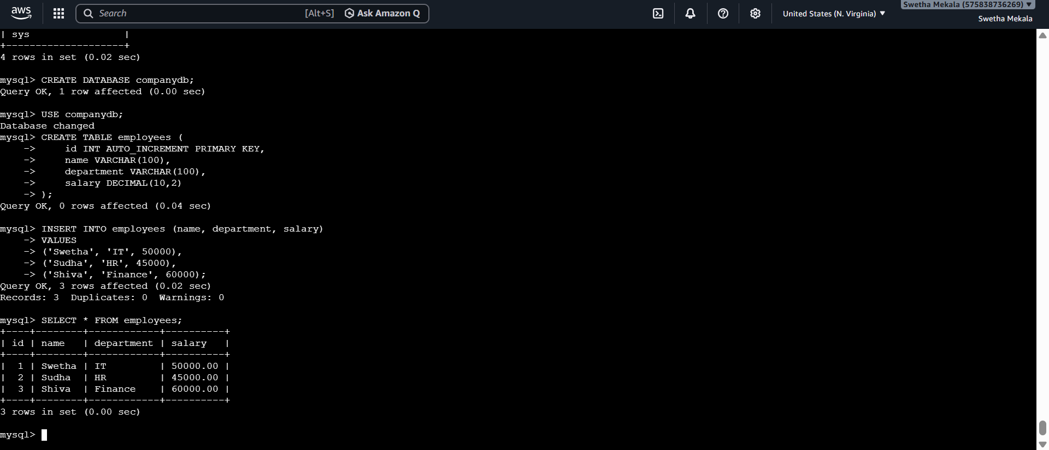

Launch MySQL RDS Instance
Prerequisites
Before creating the RDS instance, ensure you have:
- AWS account
- Ubuntu EC2 instance
- MySQL installed on EC2
- Default VPC available
- Security group available
- AWS Region selected (e.g., US East (N. Virginia))
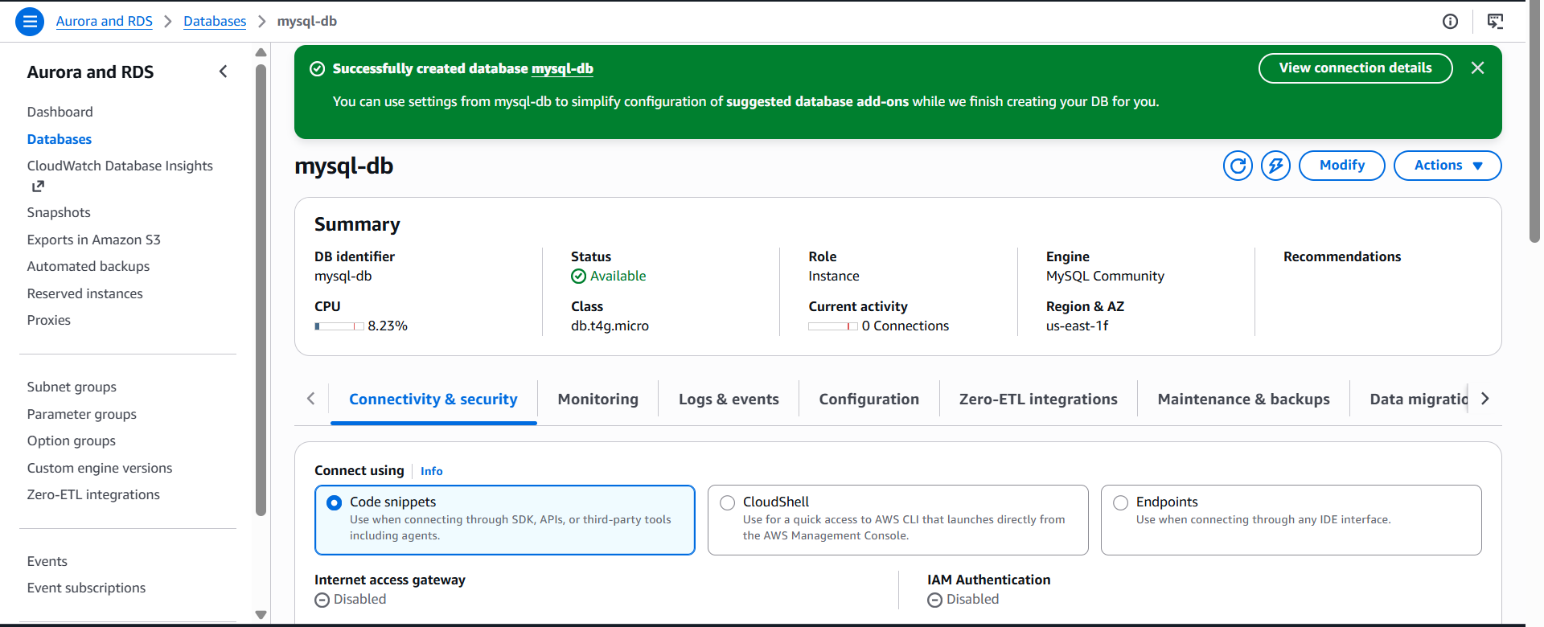
Configure Multi-AZ.
Select the MySQL Database
Click your MySQL RDS instance.
Example:
mysql-db
Make sure the status is:
Available
Modify the Database
Click the Modify button at the top of the page.
Locate "Availability & Durability"
Scroll down until you find:
Availability & durability
Enable Multi-AZ
Under Multi-AZ deployment, select:
Create a standby instance (recommended for production usage)
This creates a standby database in another Availability Zone for automatic failover.
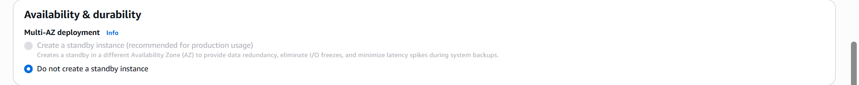
Take backup of DB and restore the DB.
Verify the Database
Log in to MySQL.
sudo mysql
Display the available databases.
SHOW DATABASES;
Select your database.
USE companydb;
Verify that the table contains data.
SELECT * FROM employees;
Exit MySQL.
EXIT;
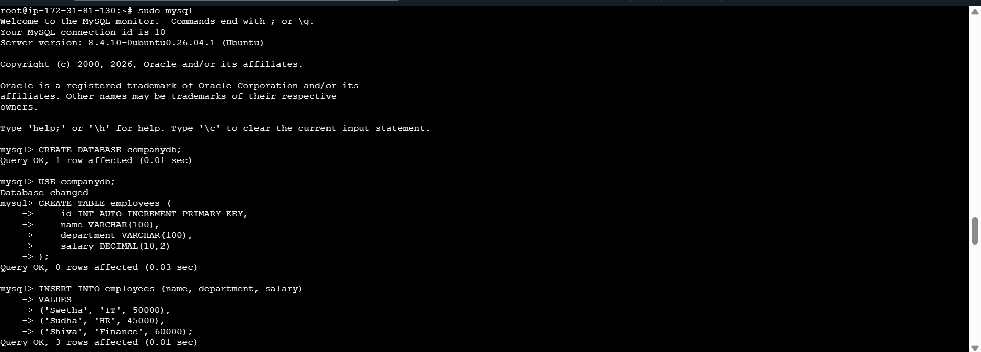
Restore the Backup
Restore the backup into the new database.
sudo mysql companydb_restore < ~/backups/companydb_backup.sql
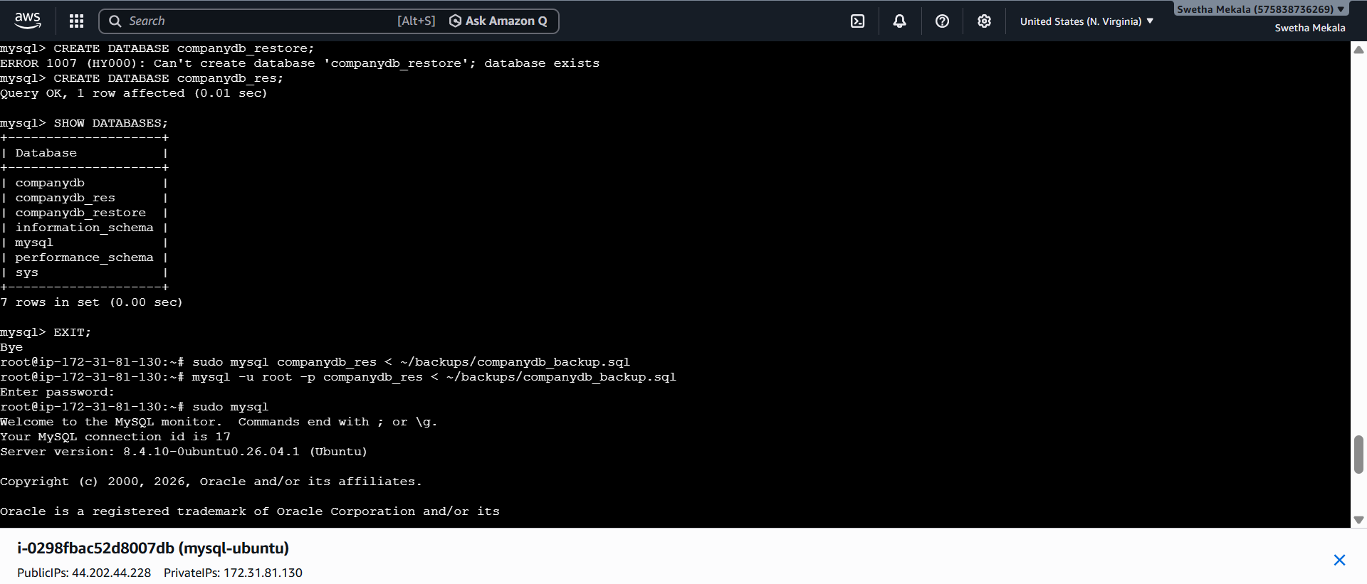

Verify the Restored Database
Log in to MySQL.
sudo mysql
Select the restored database.
USE companydb_restore;
Display the tables.
SHOW TABLES;
Verify the restored data.
SELECT * FROM employees;
Exit MySQL.
EXIT;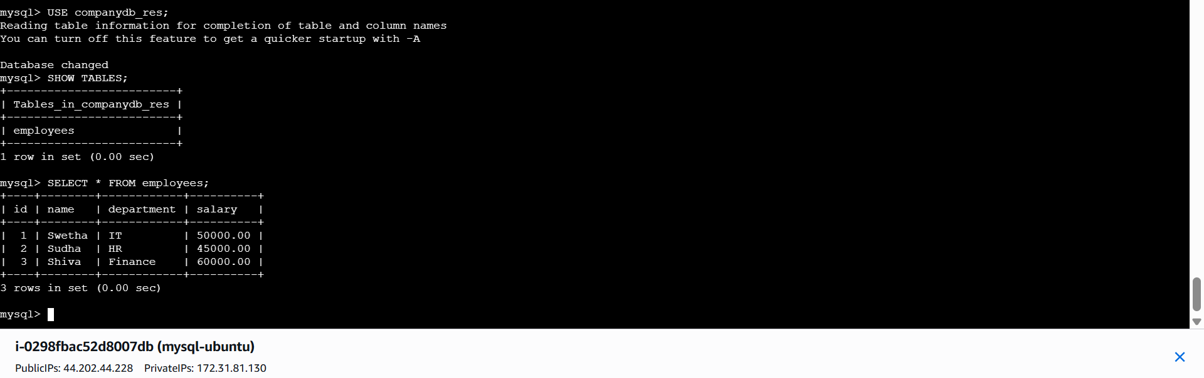
Create read replica.
AWS Console Flow
AWS Console
│
▼
Amazon RDS
│
▼
Databases
│
▼
mysql-db
│
▼
Actions
│
▼
Create read replica
│
▼
Configure Replica
│
▼
Create read replica
│
▼
Wait until Status = Available
│
▼
Verify Replication
